Report: “Buy-Low” FX Trading Algorithm (AUD -> NZD)

# 1) What the algorithm is trying to do

The goal is to exchange NZD into AUD more favourably by leaning into “cheap” periods for AUD/NZD. In other words, we add to the NZD -> AUD position on days when the exchange rate looks low relative to its recent history. We place buys only when conditions are attractive, and we keep the total position within a steadily expanding monthly “envelope” so that exposure ramps up in a controlled, predictable way over time.

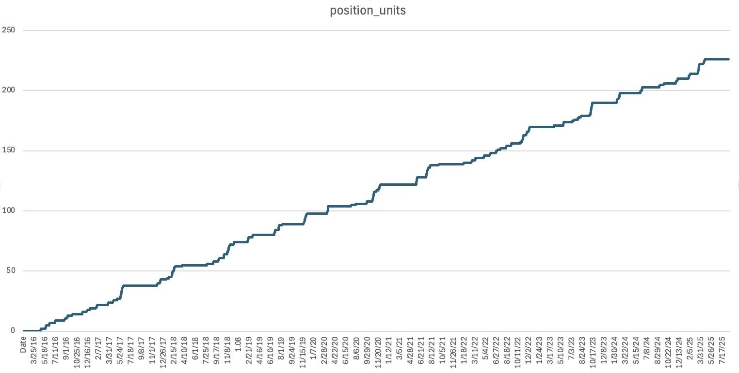

# 2) The inputs

* A CSV file with two essential columns: ‘Date’ and ‘Close’ (Close is the AUD/NZD close price on each date).
* A set of configurable parameters (with sensible defaults) that govern how sensitive the signals are, how much we buy per signal, and how quickly the allowed position grows over months.
* The size of one “unit” of buying, e.g. ‘900,000 NZD per unit’ by default.

# 3) The outputs

* A CSV file with daily features, buy decisions, position, cash flows, and equity in NZD.
* A summary table that checks the month-end position stays inside its allowed band.
* A chart with three panels: price and buy dots; z vol; and a “z-score” panel showing when price was statistically cheap.

# 

# 4) How “cheap” is measured (the features)

The algorithm blends several simple measures of “cheapness” and “stress.” Each one is normalised so we can combine them consistently.

1. Price z-score (z): compares today’s price to its recent average, scaled by recent variability. When ‘z’ is negative and large in magnitude, price looks cheap versus its own recent norm.
2. RSI (Relative Strength Index): a common “oversold/overbought” gauge. We focus on low RSI values (oversold), which often coincide with short-term weakness.
3. Volatility regime (vol\_z): a z-score of recent volatility. We avoid the extremes: if volatility is very low (market asleep) or very high (panic), we scale back. The best spot is the middle.

These measures are calculated from the historical price series and updated day by day.

# 5) Turning features into daily buy decisions

We create a single ‘score’ each day that sums up all signals and then map that score to an integer number of “units” to buy.

* Weighted blend: we give weights to z-score and RSI. By default the z-score carry more weight and RSI adds confirmation.
* Volatility gating: the score is reduced if volatility is unusually low (unreliable signal) or extremely high (crowded, stressed conditions). Middle-of-the-road volatility is rewarded.
* Daily cap: we cap the number of extra units per day to avoid outsized single-day growth.

Intuition: the more boxes that say “this is cheap,” the higher the score, and the more units (within caps) we buy.

# 6) The monthly “position envelope” (risk control and pacing)

Beyond day-to-day signals, we also control how ‘large’ the overall position is allowed to be by the end of each month. This prevents the strategy from running too hot during extended cheap periods and ensures a steady, planned increase in exposure over time.

* We assign a ‘global month index’ starting at 1 for the first month in the dataset, then 2, 3, and so on—never resetting each year.
* The ‘ideal month-end position’ (in “units”) grows linearly:
  + ideal = 2 × month\_index.
  + For example: Month 1 → ideal 2 units; Month 2 → ideal 4; Month 3 → ideal 6; etc.
* We allow a ‘band (envelope)’ around that ideal, e.g., ‘ideal ± margin’ with a default margin of 4 units. So Month 3 has an ideal of 6 and an allowed range of 2 to 10 units.
* An optional ‘hard cap’ can stop total units from ever exceeding a set maximum.

Big picture: this is our governor. It keeps the total position size within plan, even if signals are enthusiastic.

# 

# 7) Position, notional flows, and equity

* Unit size: each unit represents a fixed NZD amount to convert (default ‘900,000 NZD per unit’). When we buy k units in a day, that’s k × 900,000 NZD converted to AUD at that day’s closing rate.
* Cash and holdings:
  + Cash in AUD decreases by the daily AUD spent.
  + Holdings are valued as ‘cumulative units × NZD-per-unit × current price’ (converted to AUD by the rate itself).
  + Equity = seed AUD + cash + holdings.

# 8) What the chart shows

1. Top panel (Price): the AUD/NZD rate with bright orange dots on buy days.
2. Middle panel (risk proxies): two moving-average-style lines used as volatility proxies; these help contextualise the regime.
3. Bottom panel (z-score): the price’s z-score through time, with a dashed line at the buy threshold. Filled areas and vertical markers highlight when price dipped below the threshold and buys were triggered.

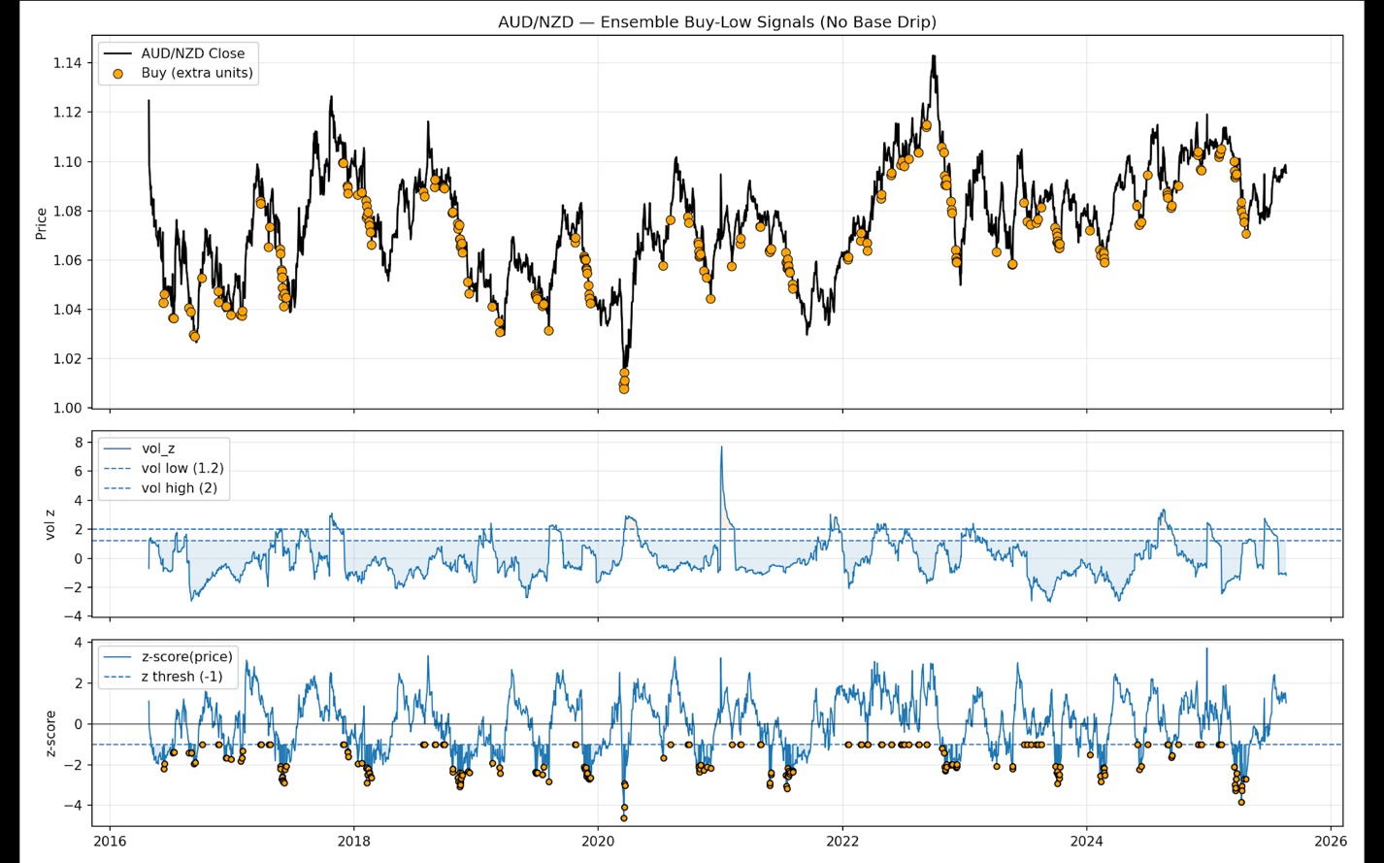

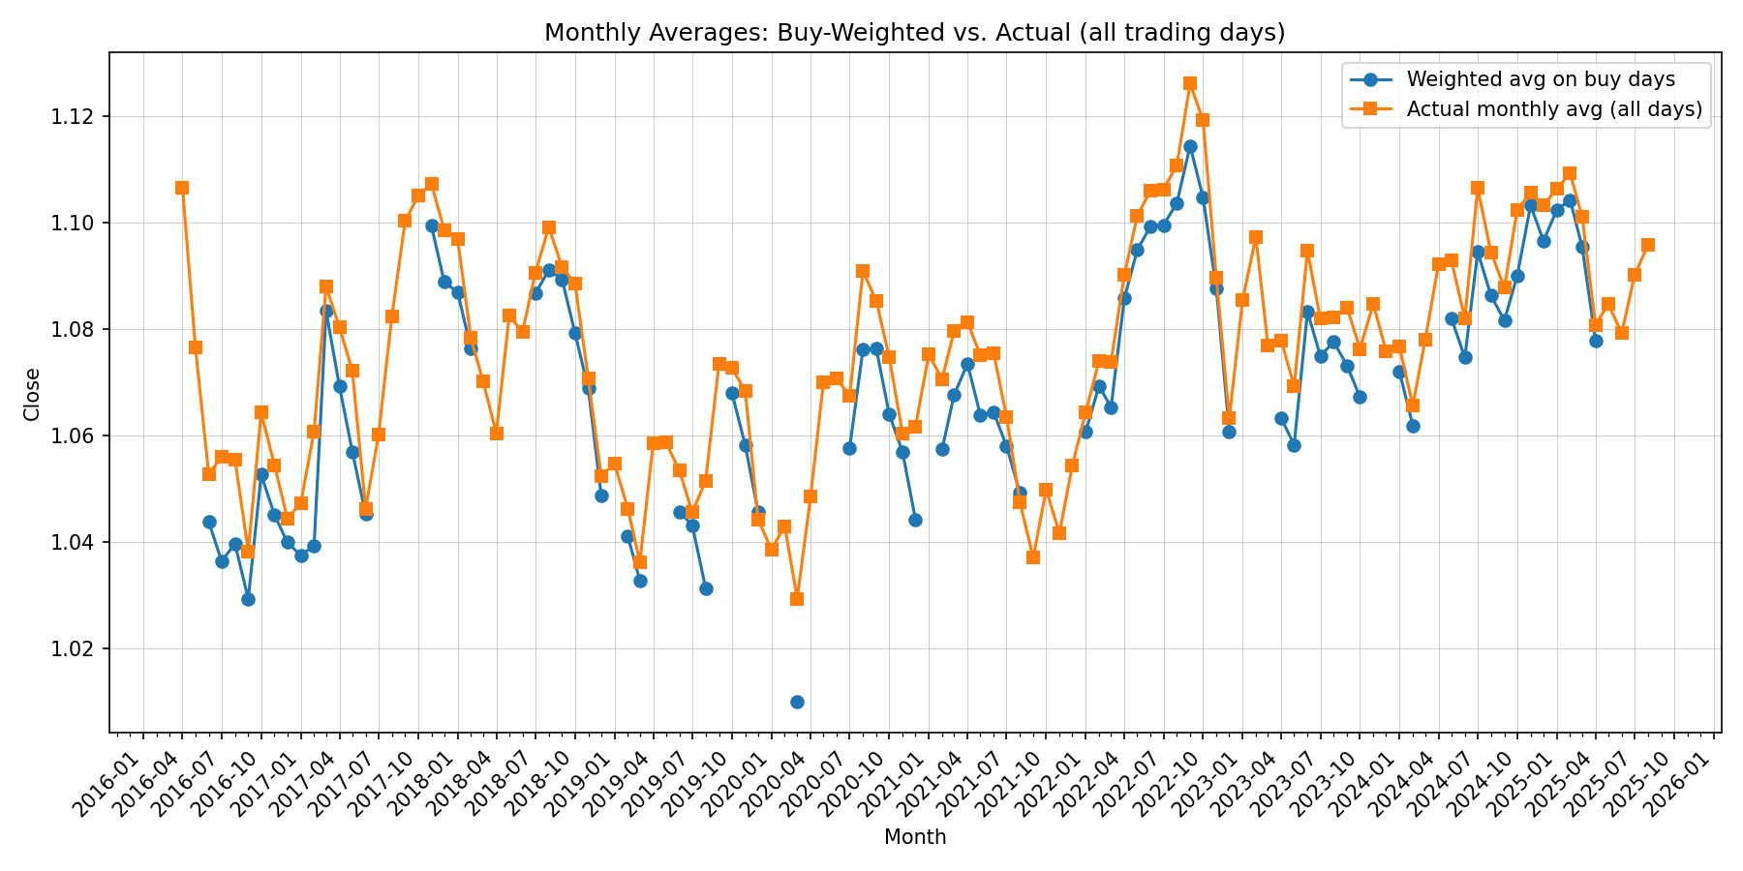

# 9) Key parameters you can tune (plain-English guidance)

“How sensitive are we to dips?”

Lower the z-threshold or raise the weights on z/ RSI to buy more readily; raise the threshold or lower weights to be pickier.

“How much do we buy on a good day?”

Increase ‘units-per-score’ or ‘max-extra-per-day’ to scale up; reduce them to slow down.

“How fast does the overall exposure ramp up?”

The envelope controls this: the monthly ideal is ‘2 × month_index’. Increase this factor or reduce the margin to ramp faster and tighter; do the opposite to ramp slower or give more slack.

“Do we avoid sleepy or panicky markets?”

The volatility gates reduce buys in very low or very high volatility. You can loosen or tighten these gates.

“Unit size and cap:”

Adjust ‘NZD per unit’ and the optional ‘maximum position units’ to fit budget and risk limits.

# 10) Operating the script in practice

* Point it at a price file with Date and Close.
* Choose (or keep) defaults for thresholds, weights, unit size, and envelope margin.
* Run it; collect the CSV, the plot, the Sharpe printout, and the month-end envelope report.
* Review buys on the chart, confirm exposure stayed in range, and decide if you want to make the settings more or less aggressive.